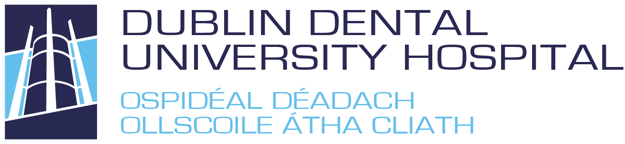

BENCH TEST PREPARATORY COURSE APPLICATION FORM

I would like to enrol in the Bench Test Preparatory Course to be held 31st March & 3rd April 2023.

Name

Address

Email Address

Mobile No.

The fee for the course is €1,500

Method of payment: Bank Transfer to:
Dublin Dental Hospital
Ulster Bank
College Green
IBAN : IE63ULSB98501012032827
Bic : ULSBIE2D

Please email a copy of the receipt of this payment & any queries to niamh.leonard@dental.tcd.ie
Signature: __________________________________ |  | Date: _________________

